Handout Two
Autodesk Inventor Professional Registration and Download Instructions
Pete Sloane, Course Mentor, 2012-2013 Season

You will be downloading a fully functional version of Autodesk Inventor Professional. The only difference between this educational version and the commercial version is that print output is watermarked with “Educational Version of Autodesk” on perimeter. You must have Windows XP, Vista or Windows 7 operating systems. Before starting it is useful to know whether you have a 32bit or 64 bit operating system (see step 10, below). In addition, you may download a free trial of Tutorials to quickly get up to speed on Inventor basics (see step 14, below).

1. Google Search for “autodesk inventor for first robotics” or go directly to Autodesk Student Home Page at: http://students.autodesk.com/?nd=first_home&tagent=FRC-2012-LA-1-6-2012

2. Click on “Join the Education Community” in the Easy As 1-2-3 box on right:

3. Fill out the first page of the registration form with your e-mail address (it will be used for validating your registration) and whether you are a student or mentor, then continue to Step 2:
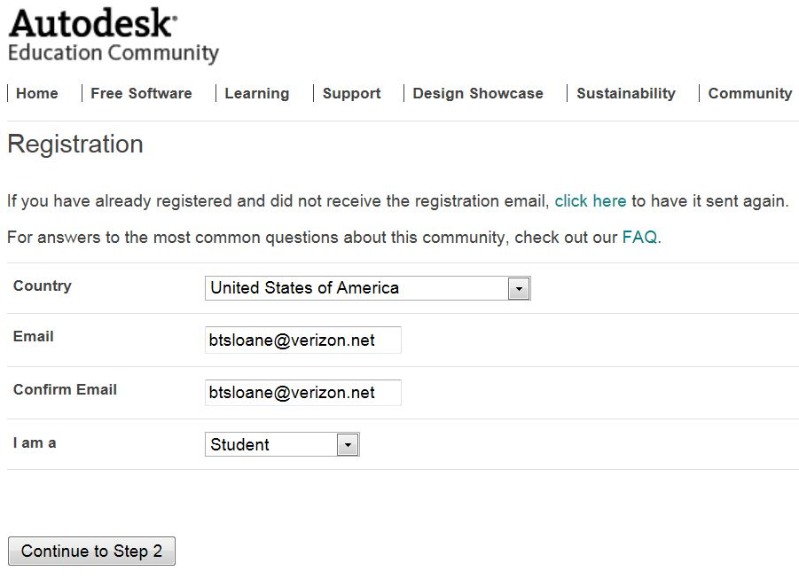
4. Complete the form and be sure to check of the Terms and Condition box. Enter your school and school’s URL (www.parkschool.net or http://www.edline.net/pages/Dulaney_High_School). Park School is in Baltimore City. If you can’t find Park School on the list, it can be manually entered. Then go on to step 3.
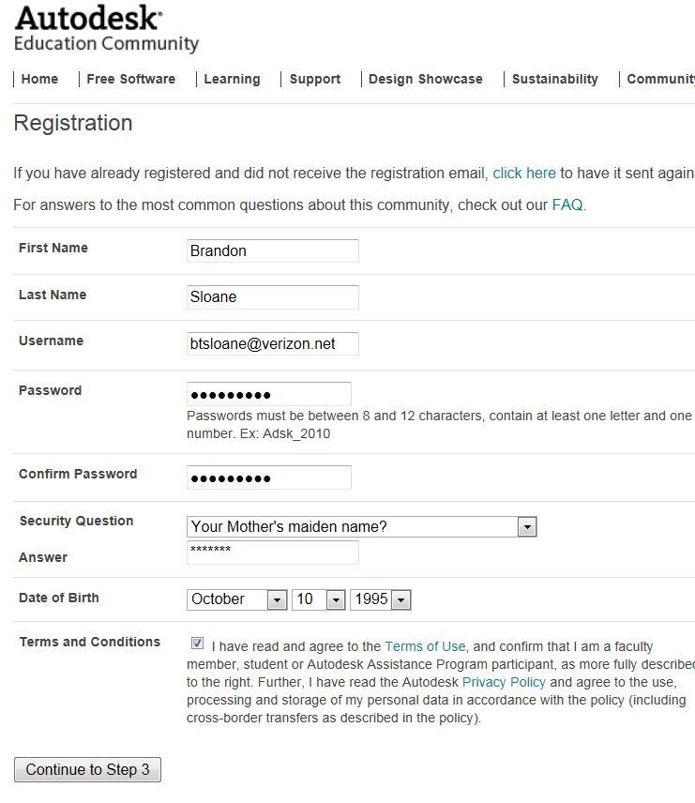
5. It is easiest to validate registration by going to your e-mail and clicking on the link that is provided. On the Step 3 page, there are alternate ways to validate via facebook and mobile phone which are not required.

6. Congratulations, you are now a registered student/mentor in the Autodesk Community.

7. Go back to student home page and click on second tab in middle of page “Free Software”:


8. Login to Autodesk Community via the student home page (student.autodesk.com), upper right corner.
9. Click on “Go To Download Center”:

10. Find out if your computer is running a 32-bit or 64-bit version of Windows:
For Window 7 or Vista Users in Windows 7 or Windows Vista: Open System by clicking the Start button , right-clicking Computer, and then clicking Properties. Under System, you can view the system type.
For Windows XP: Click Start, Right-click My Computer, and then click Properties. If you don't see "x64 Edition" listed, then you're running the 32-bit version of Windows XP., If "x64 Edition" is listed under System, you're running the 64-bit version of Windows XP.

11. Select Autodesk Inventor Professional from the list and choose version 2013, English language and whether you have a 32bit or 64bit Windows Operating System. Then select Next.

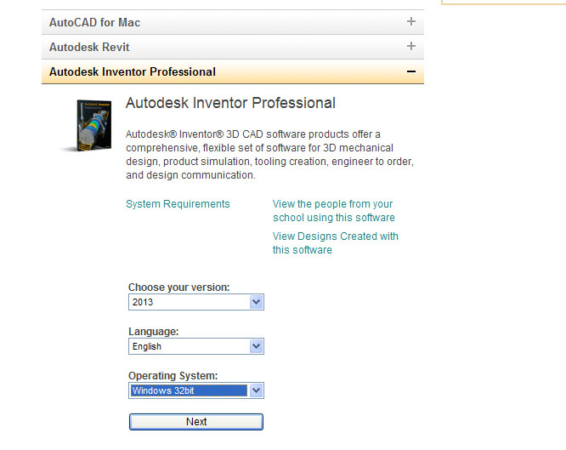
12. You will be provided with a Serial number and Product|Key which you should print out or write down for future reference:
13. Follow the remaining prompts to download and install. Note: If you happen to have an installation disk for Inventor 2013, you can skip the download and install from the disk, saving much time! If you don’t have the disks, then there are two methods, one that downloads, installs, and fills in your serial number and product key for you, all in one step. A slightly longer method allows you to download the .exe file first to the hard drive then run later. Click on the arrow to the right of “Install Now” to see all options. In the case of installing later, you will need your serial number and product key:
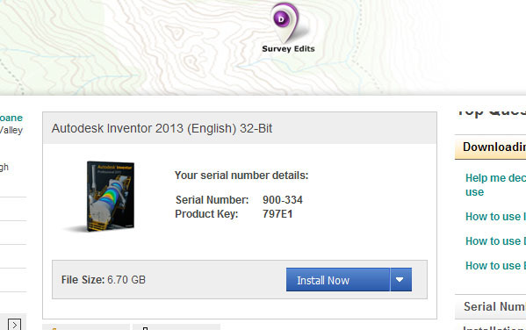
14. Finally, there is an excellent on-line course from TEDCF publishing (http://www.trainingtutorial.com/) to learn CAD. The courses relevant to Team 1719 and Inventor can be found at http://www.trainingtutorial.com/Solid_Modeling2013_Lessons.htm and are highly recommended by your mentors. The first 17 lessons (about 5-10 minutes each) are free and give a very nice introduction to the user interface, sketching, 3D parts creation and basic assemblies. If there are students that finish these lessons and are interested on going further, the team is considering purchasing the entire 99 lesson intro course (the course listing is also seen at http://www.trainingtutorial.com/Solid_Modeling2013_Lessons.htm ). Better yet, the free trial can be downloaded to play in a very nice video player interface right on your computer at http://www.trainingtutorial.com/Autodesk_Inventor_2013_Training_Free_Trial.htm.

